Time Trackers in Dynamics 365 CE

There is a Time Tracking feature in Dynamics 365 CE Customer Service that looks promising.
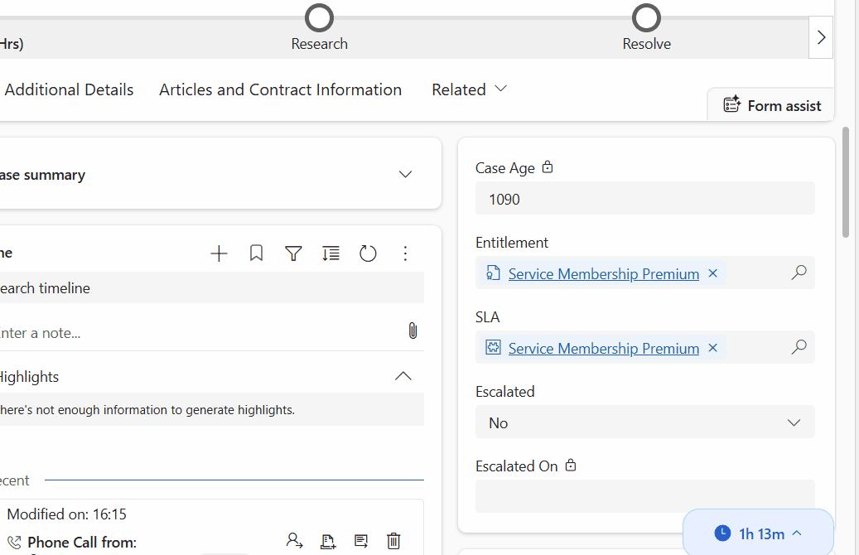
Time Tracking Widget
Time Tracking
Time Tracking widget tracks the time that every user works on a case. In the widget shows the users initials.
It is Tracking:
- Over all Automatic Time Tracking from everyone
- What is Manually Added as Time Logs
- What is added from Activities.
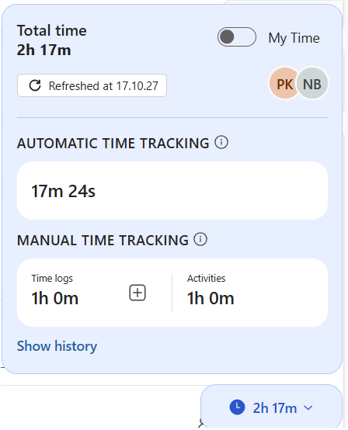
When clicking on "My Time" it shows only the time tracking related to me
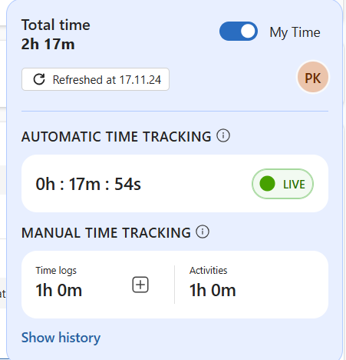
All History of Time Tracking and Logs
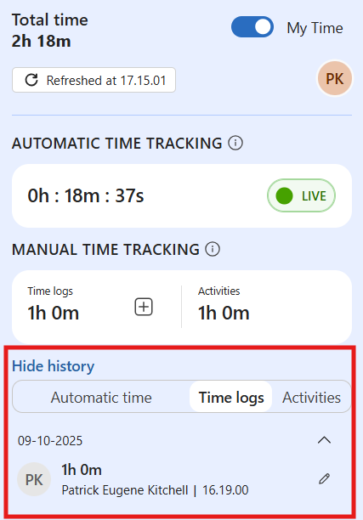
Adding Time Manually allows users to add their own time logs. This can be turned off on the properties settings.
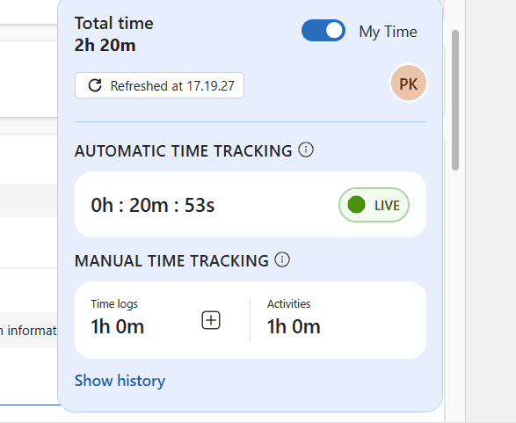
How to Enable Time tracking
The Time Tracking Component can be added to case forms and then it will show up has a widget hoovering over the from. To turn on Time Tracking just go to the Customer Service Admin Center >> Case Settings >> Case Handling Times
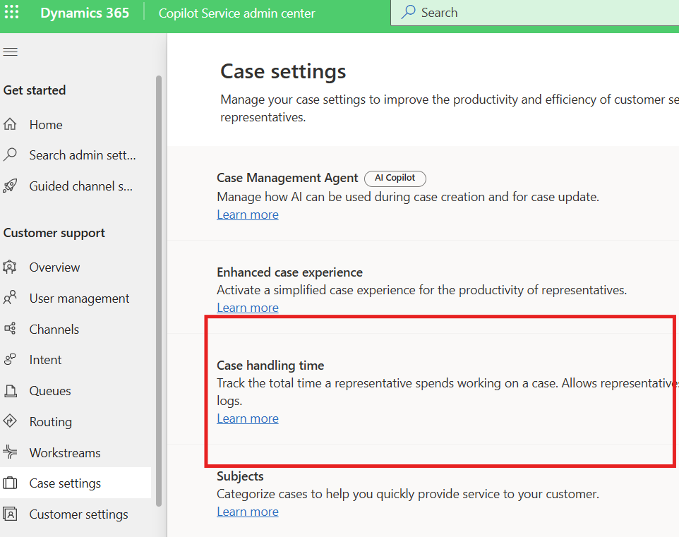
Click in into this settings to enable and set an Update Interval(minutes) - lowest is 10 minutes
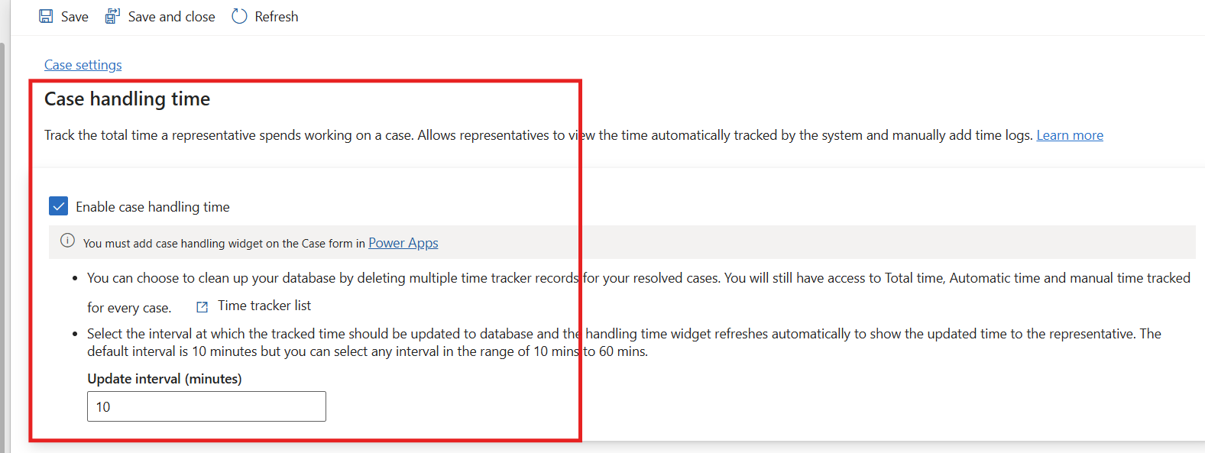
This update interval is important as the documentation says:
The app updates the database with the tracked time at regular intervals based on your administrator's configuration. If you refresh or close the browser in Copilot Service workspace or Customer Service Hub, the app records the time for the last completed interval but might not record the time from the ongoing interval. For example, if the update interval is set to 15 min, and you close the browser after 20 min, the app logs only 15 min. It might not capture the remaining 5 min, because the database wasn't updated in that time.
This leads to the need to test how the time tracking works in both Customer Service Workspace and the Customer Service Hub as it behaves differently due to the way the Customer Service Workspace handles sessions. It is important to read the Time Tracking Documentation and test.
Once Enabled
Once Tracking is enabled than it needs to be added to the Case Forms that are being used in the different apps.
First add the Handling Time Component to the Form. The component is called "Handling Time".
Properties
In the properties chose the Time Tracking Table and there is only 1 view
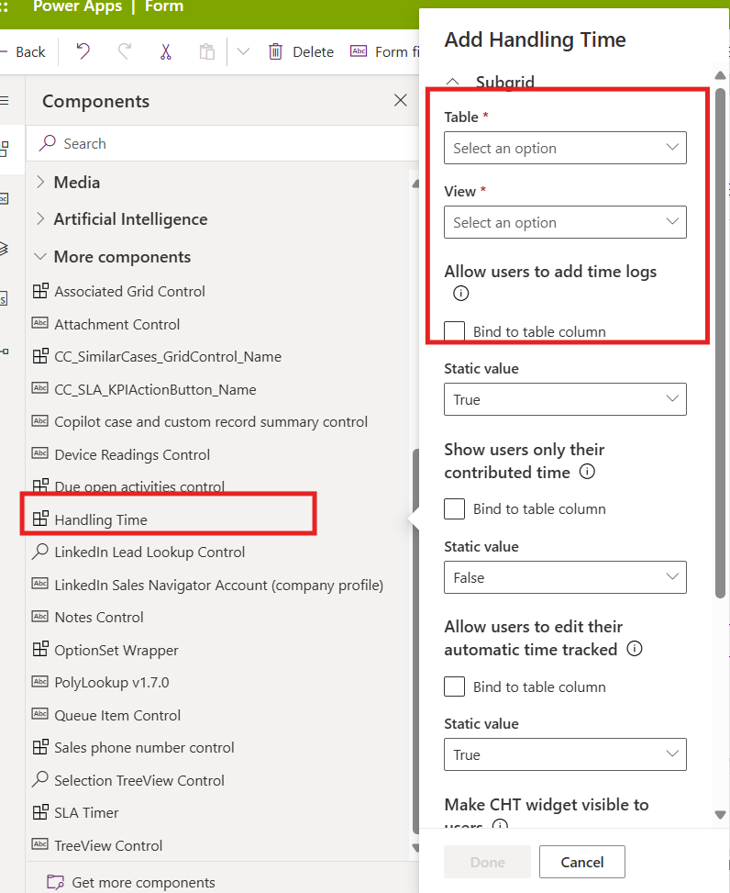
After it is on the form open the component properties again and ensure it shows regarding Time Tracking records. Remember to hide the label as the component is only used to enable the widget. This needs to be done in both the Customer Service Workspace and the Customer Service hub on all Case Forms used.
The widget is the same regardless where it is placed and it CAN'T be edited.
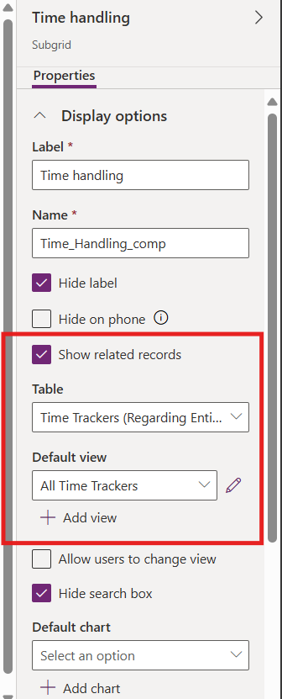

Customer Service Workspace
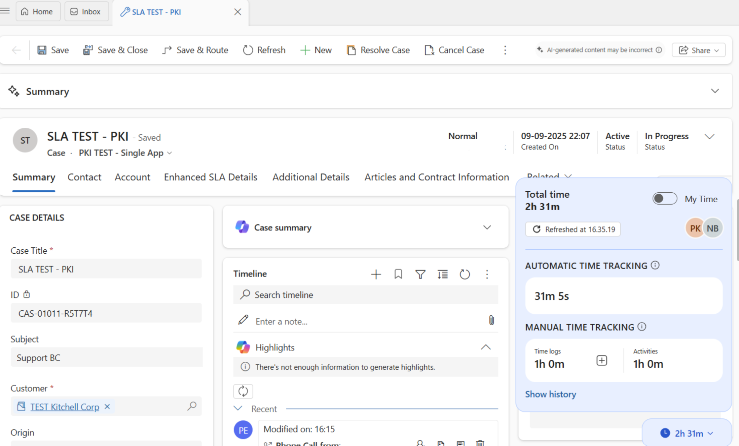
CSW
Customer Service Hub
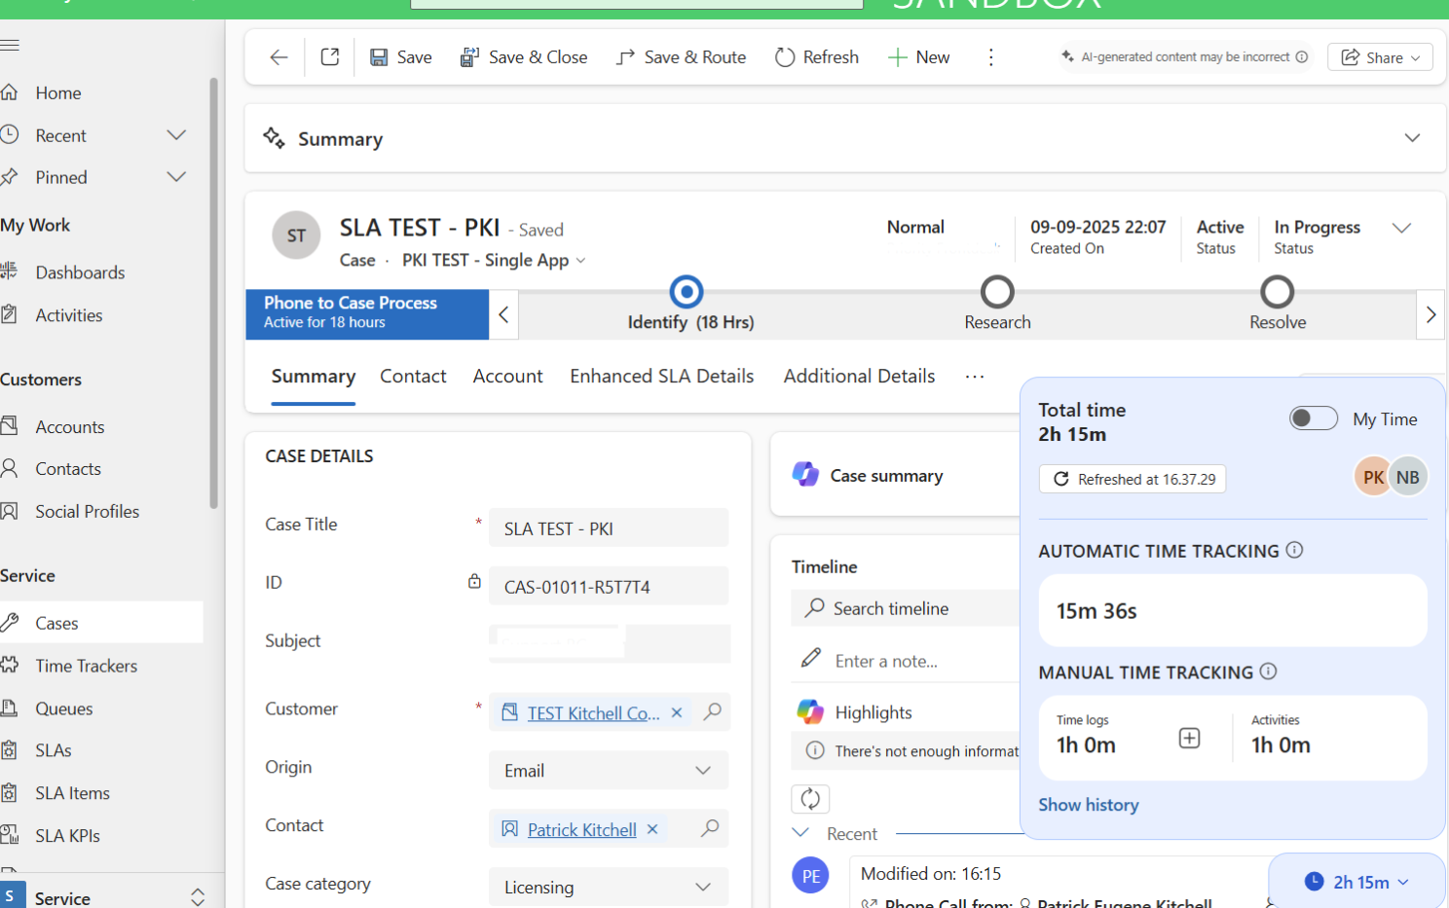
Where is the Data?
There is a time tracking elastic table in dataverse that can be added the navigation on the apps. It should noted that the Time tracking Form can not be edited and the table is locked. It is possible to add the attributes to the few and report on the data.
